**Login Logout using Servlet**

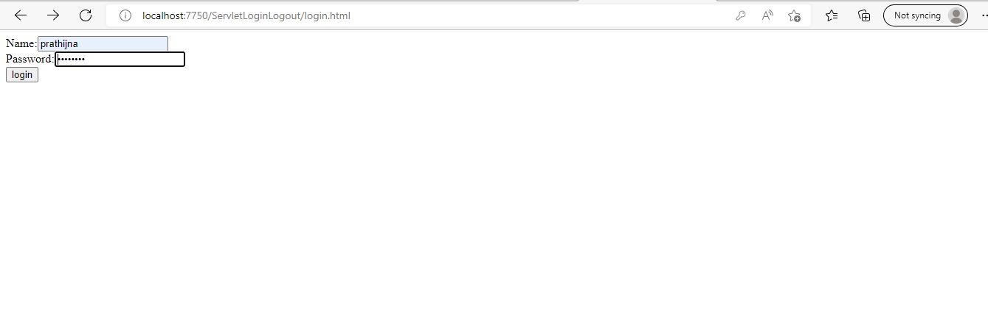

* User can enter username.
* Password is static, admin123
* User need to enter the static password.
* If user enters wrong credentials, user will not be allowed inside.

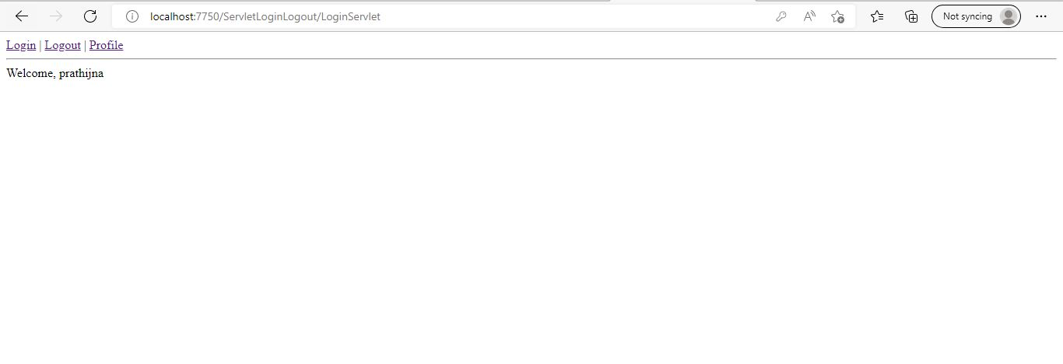

* Dashboard is displayed
* With welcoming message.
* With options to login again, logout or to view the profile

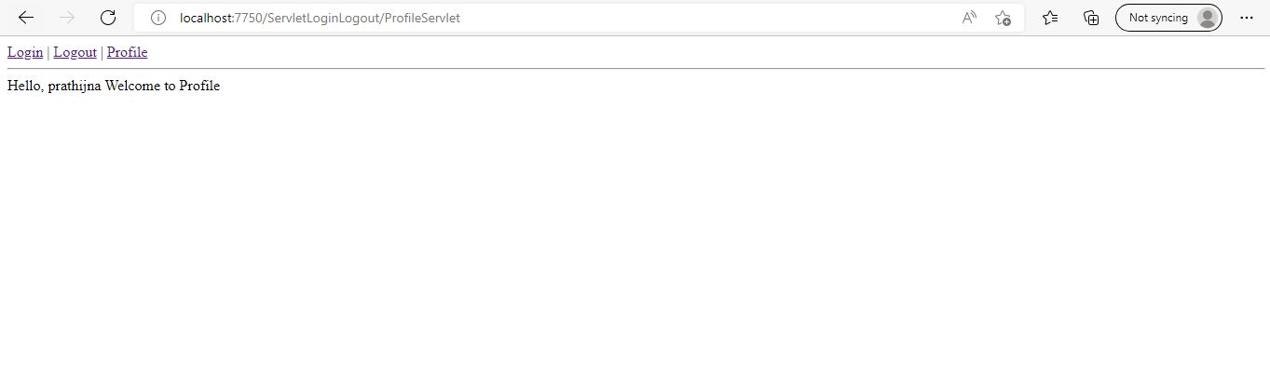

* When user wants to view the profile, user have to click on profile.
* Hello, username welcome to profile message will be displayed.

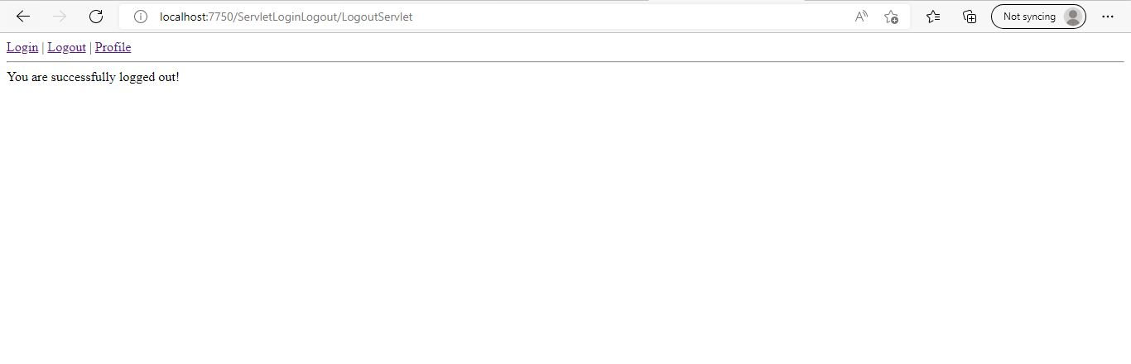

* If user wants to logout, user need to click on logout.
* You are successfully logged out message will be displayed.